MS Fabrics project
DATA ENGENIEERING/POWERbi/Data factory
Coulibaly Oumar
[Year]
Contents
Introduction 2
End to end Project Steps 2
Architecture 3
Data-engeniering expriance 3
Tenant(organization) setting / Admin portal 3
Create Workpace (From data Engenieering Experiance) 4
Create Lakehouse in the WS (From data Engenieering Experiance) 4
Create or import a notebook from LH (attached to LH ) 5
Medallions architecture 5
Bronze 5
Silver 6
Gold 8
Create a semantic model for PBI using Gold files 10
PowerBI expriance 12
Data factory experience 13
Create a new pipeline 13
Pipeline with notebook activity (Using parameters) 15
Processing (on schedule) 16

Introduction
MS facbric is a data analysis platform that breng together to a single place mutiple analysis experiances like :
Data Engenieering
Power BI
Data factory
Data science
Data Activator
And more
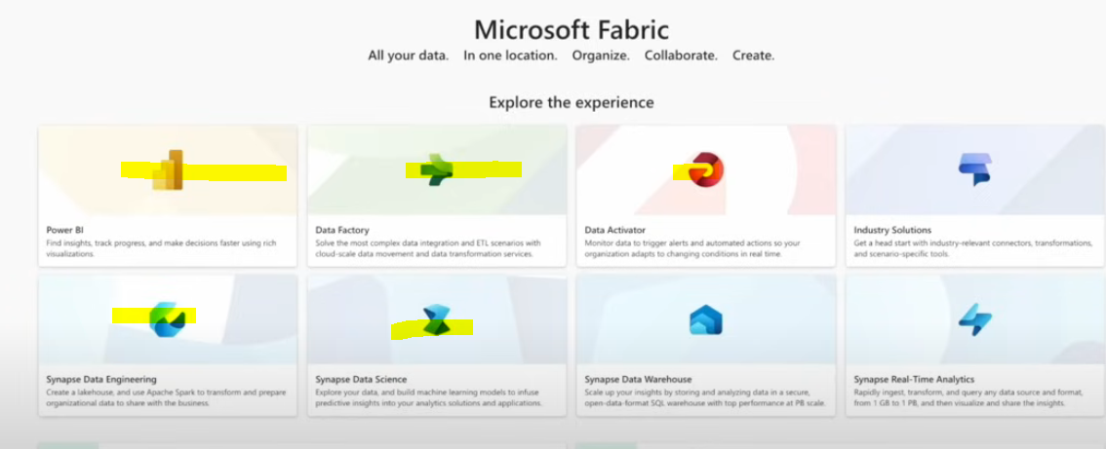

End to end Project Steps

Ref : https://www.youtube.com/watch?v=Av44Nrhl05s

Create Fabric Workpase and Lakehouse (from 3:20 to till 6:52 )

Notenbook addition in fabric (from 8:37 to 14:38)

Coding bronze layer in nootbook (from 14:40 to 21:36)

Coding Silver layer in nootbook (from 21:39 to 30:40)

Coding gold layer in nootbook (from 30:41 to 41:10)

Upadate the default sementic model for PBI (from 41:11 to 52:32)

Data factoty in Fabric (from 52:34 mn to1:03 h)

Architecture
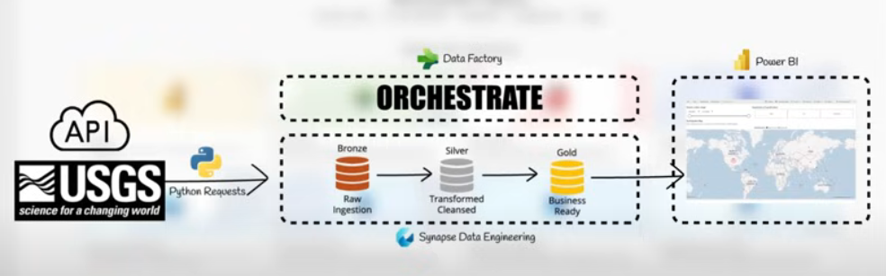

Data-engineering experience

Tenant(organization) setting / Admin portal
This is place where most of the features get enables. Please check all the restrictions you have before starting (If you are not able to see some feature you can contact your system administrator to enable that for you)
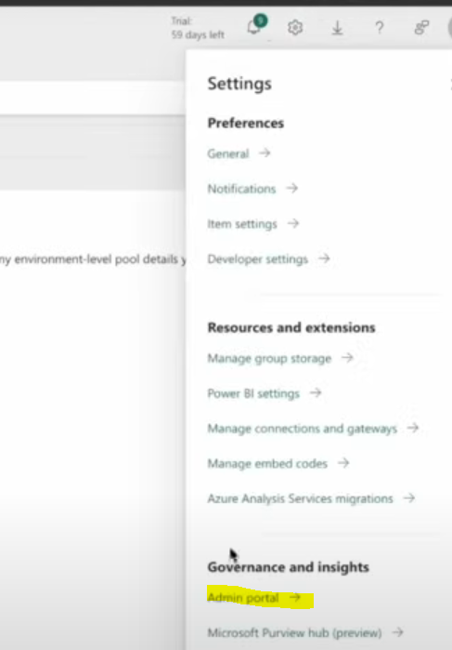
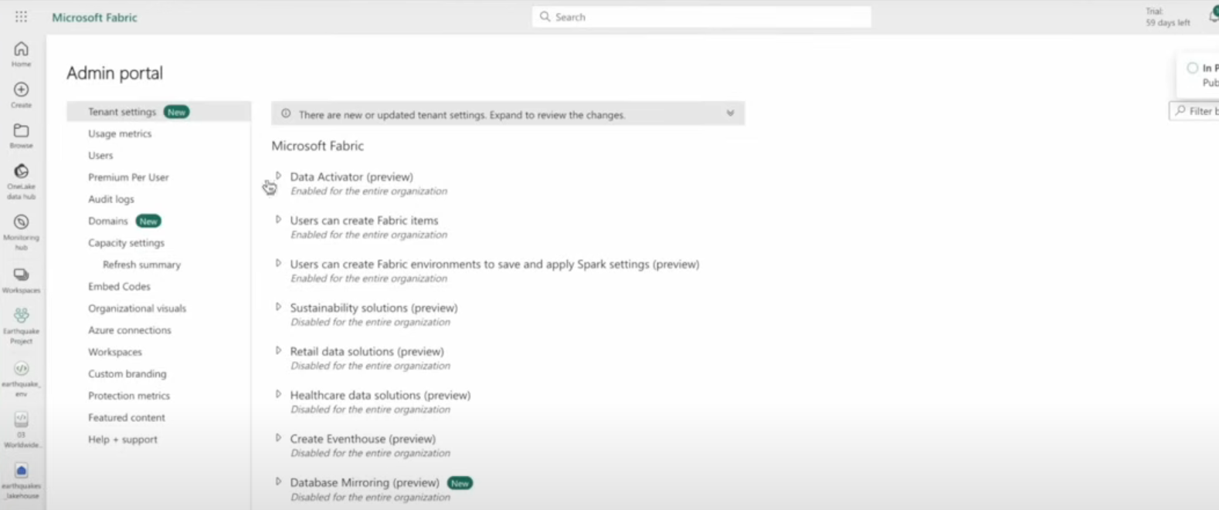

Create Workpace (From data Engenieering Experiance)

Create Lakehouse in the WS (From data Engenieering Experiance)
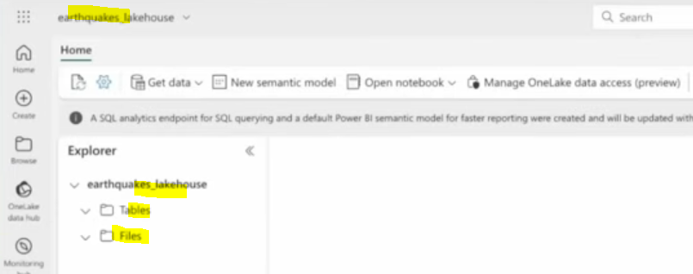

Note: creating a lakehouse in WS will create sementic model (for default data model) and SQL end point (for sql queries)
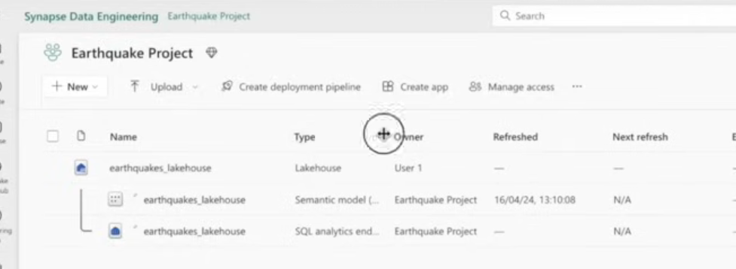

Create or import a notebook from LH (attached to LH )
To fech api data and load it to the lakehouse
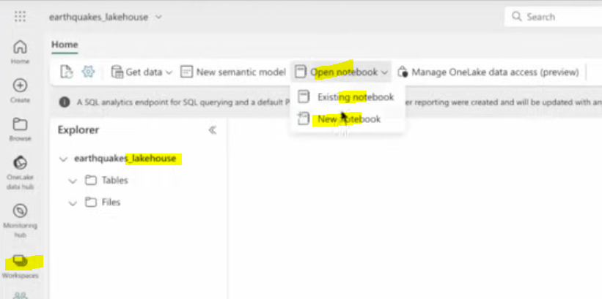

Medallions architecture

Bronze
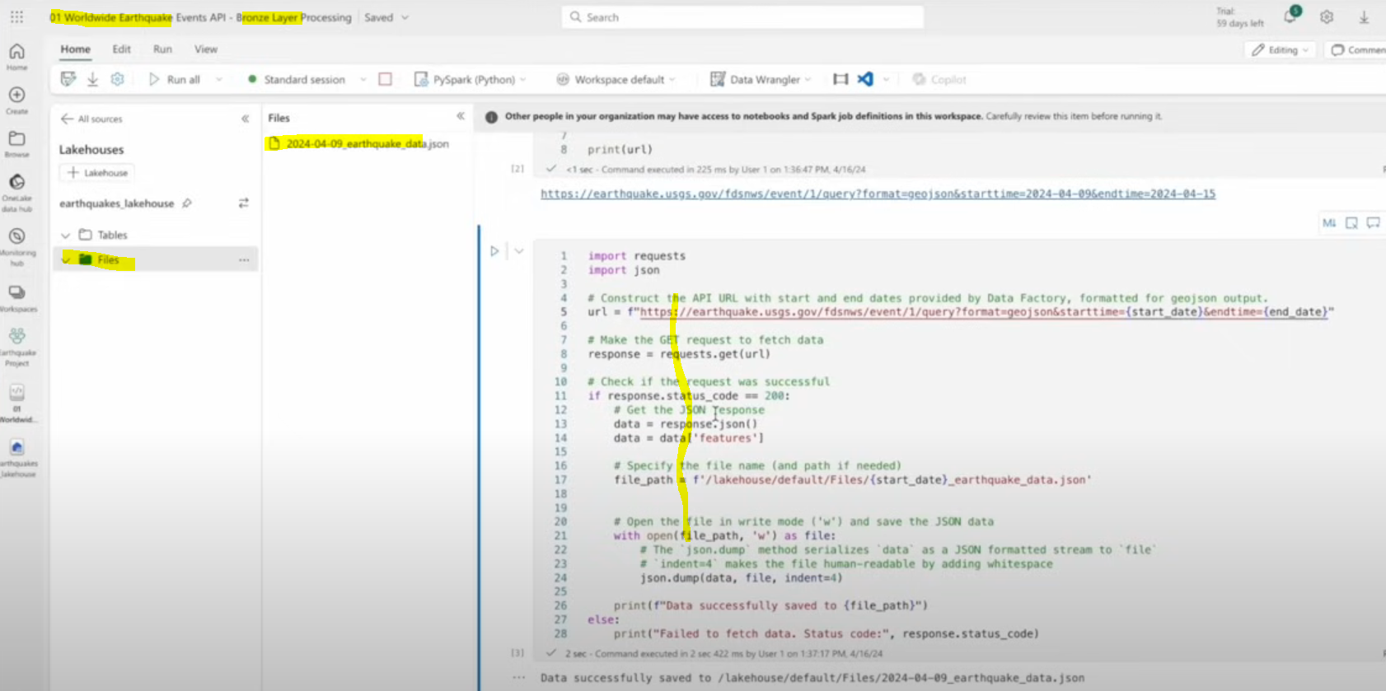
Output
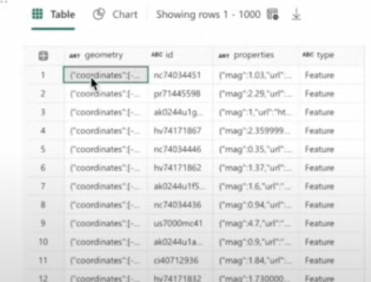

Silver
Notebook with Python code
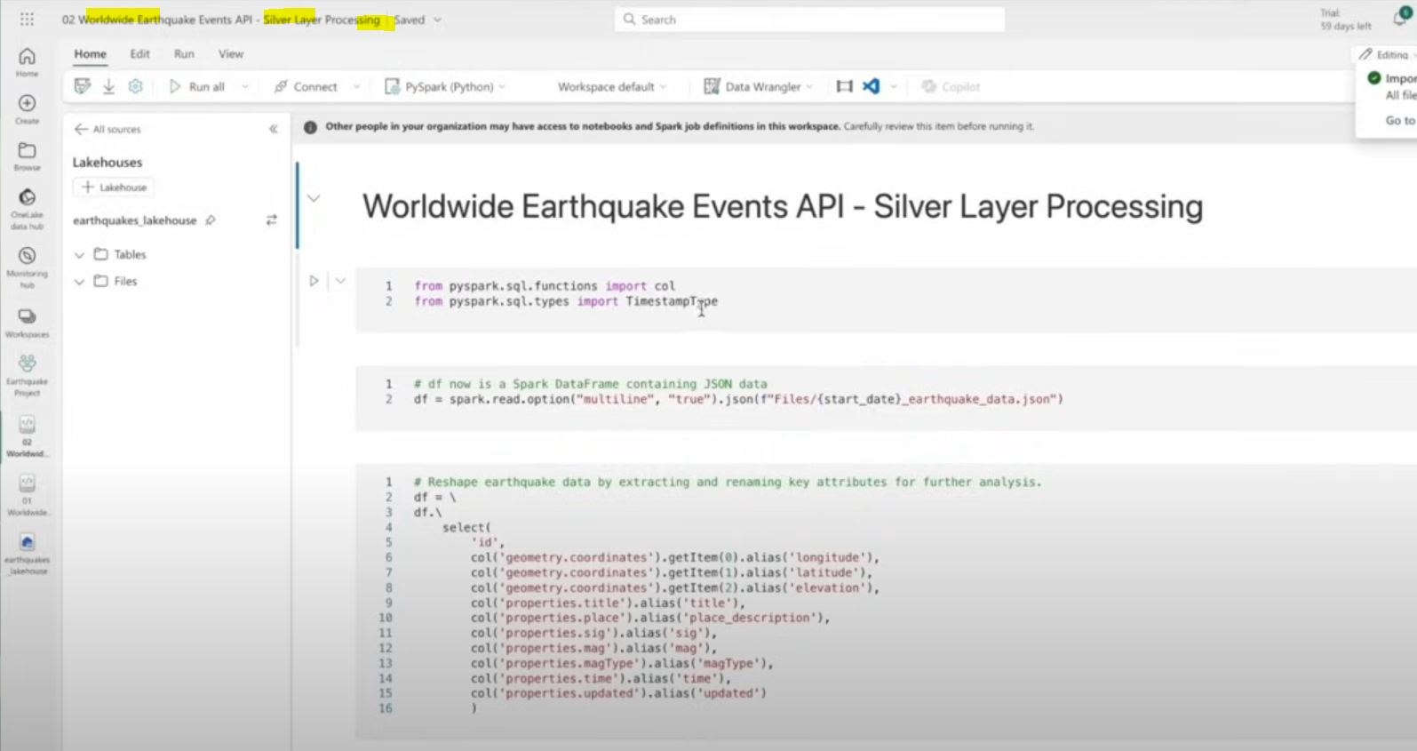
Transforming the output as delta table
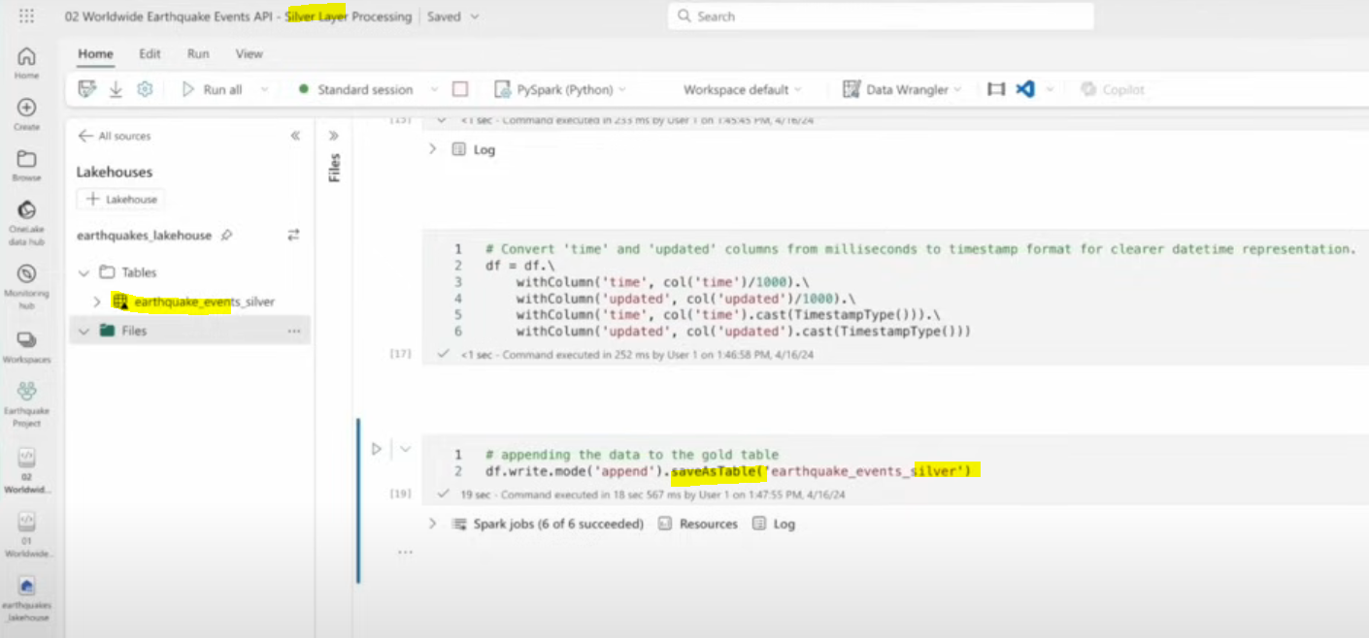
View from SQL analytics endpoint
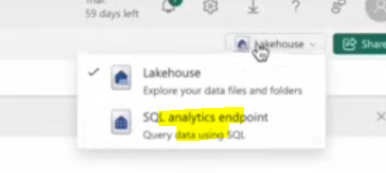
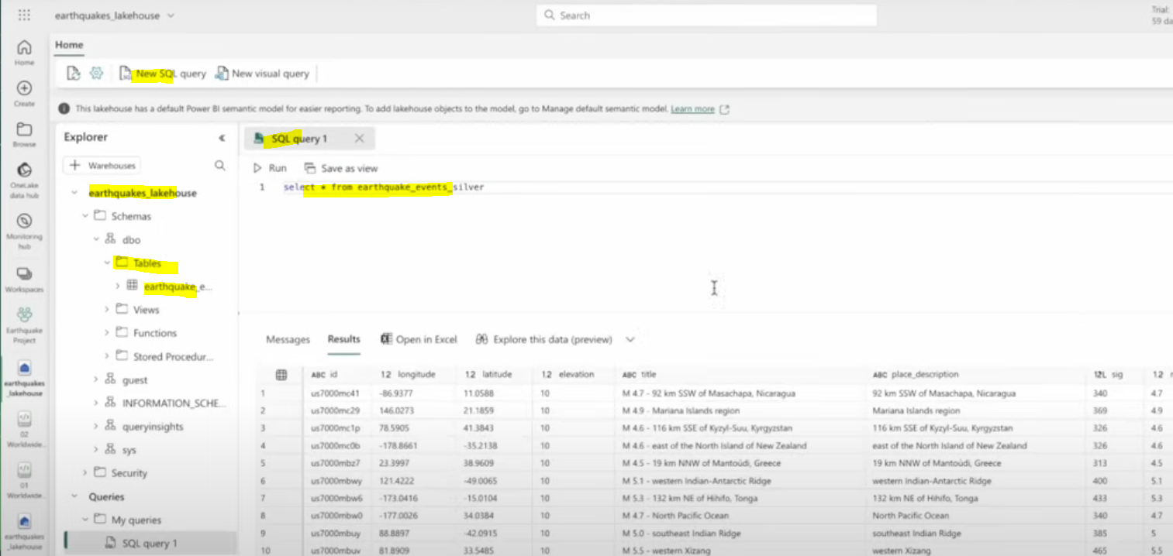
Output
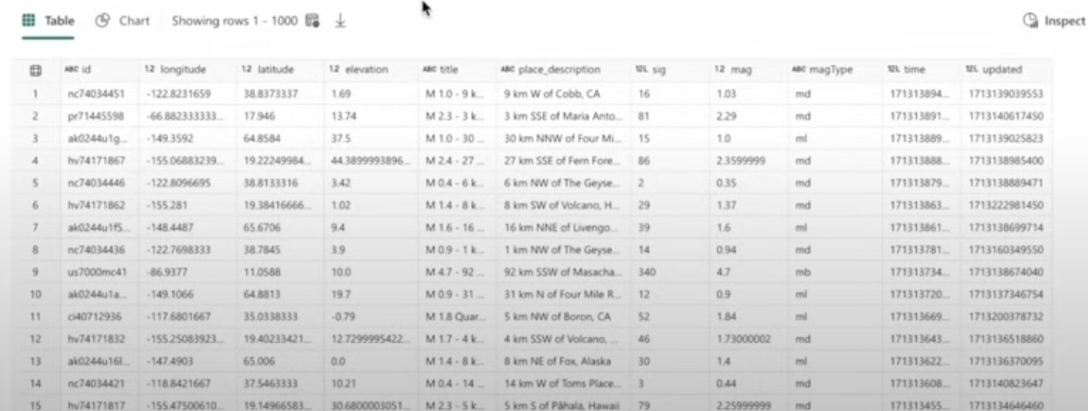

Gold

Environment/ Library installation
Install a library for python use , can be done from the WS
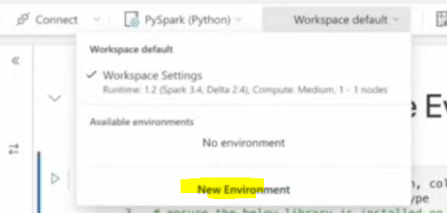

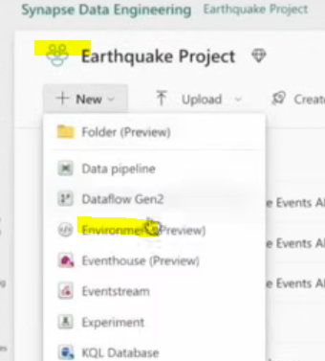
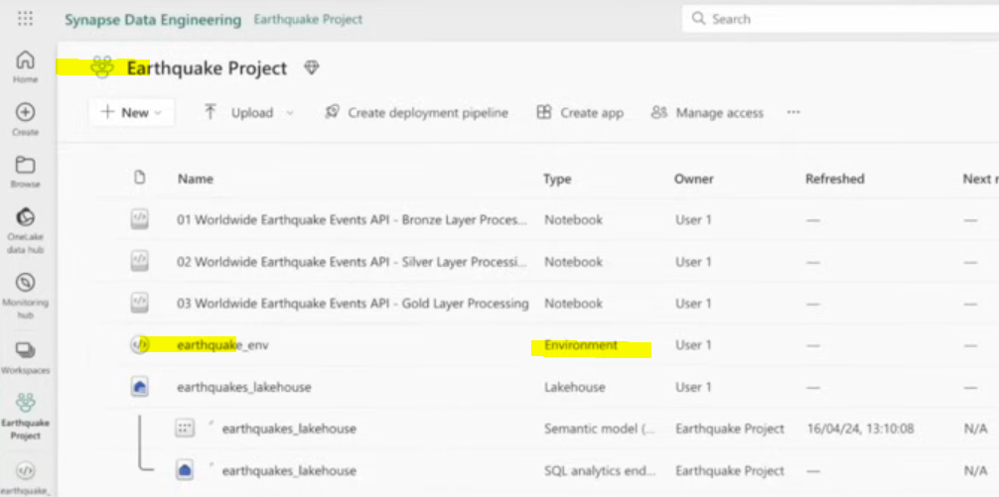
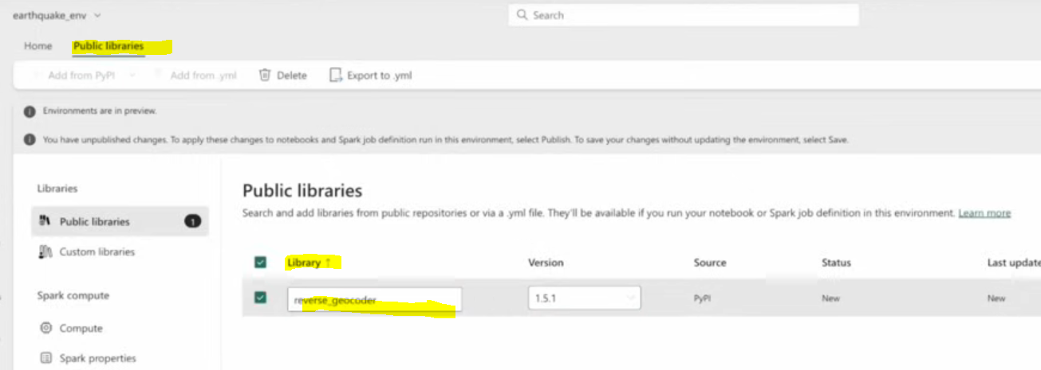

Notebook
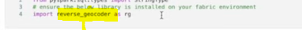
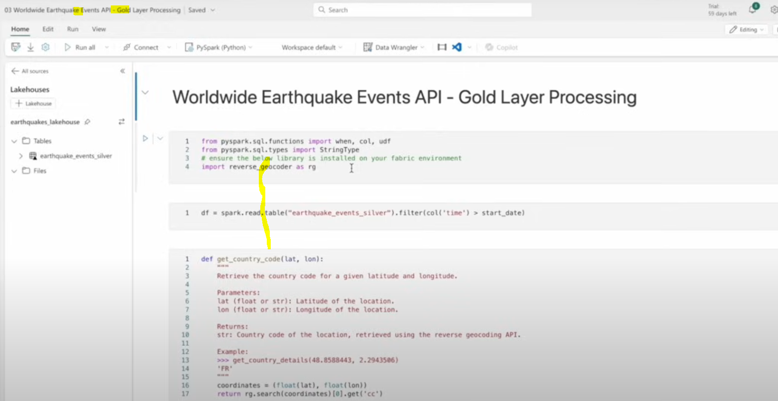
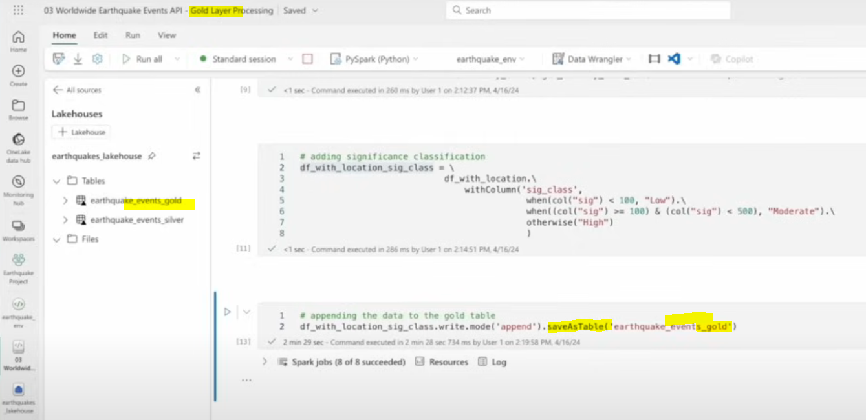

Create a semantic model for PBI using Gold files

Direct lake
is a mechanism behind the default semantic model That connect directly the file like direct query does with table in sql DB expose the update data from the files.
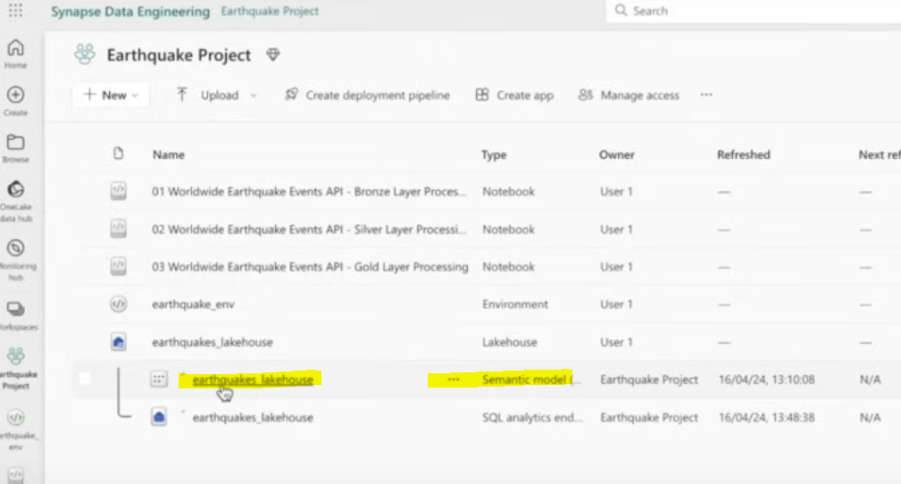

Manage the default semantic model
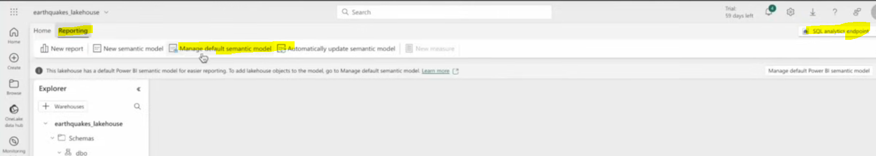
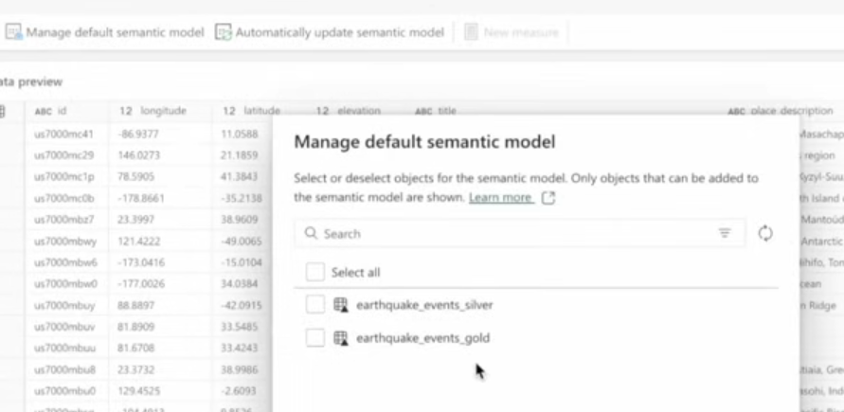
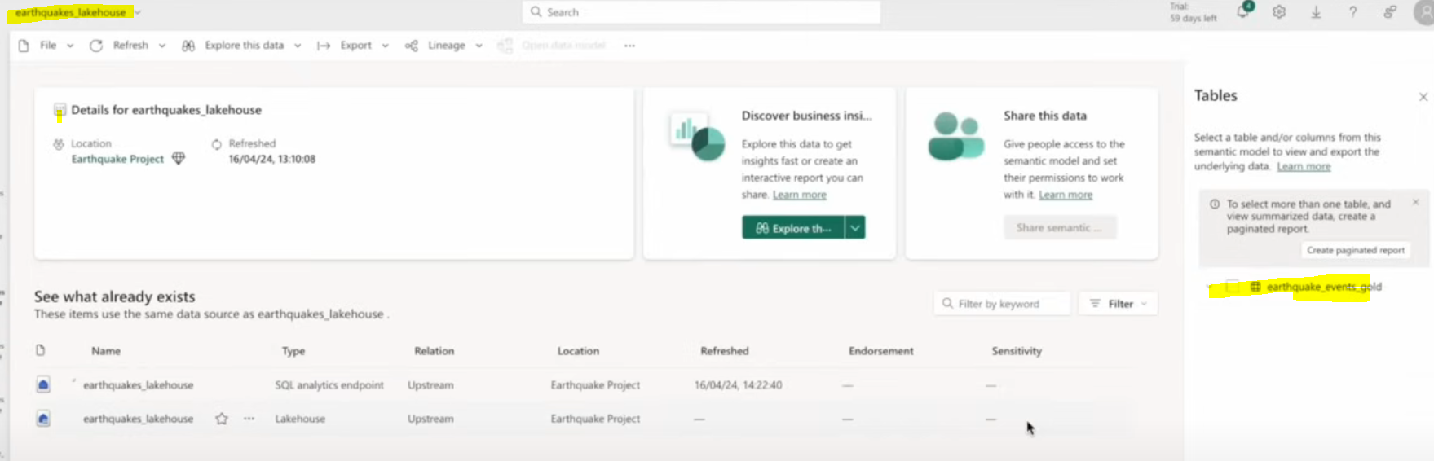

PowerBI expriance
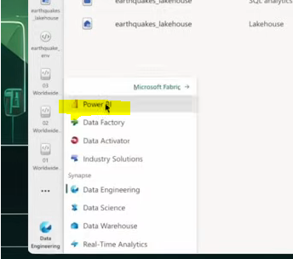
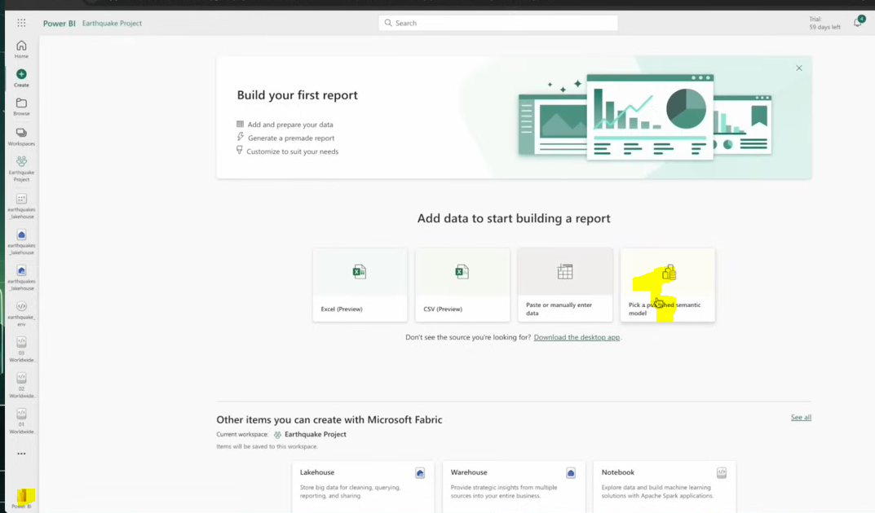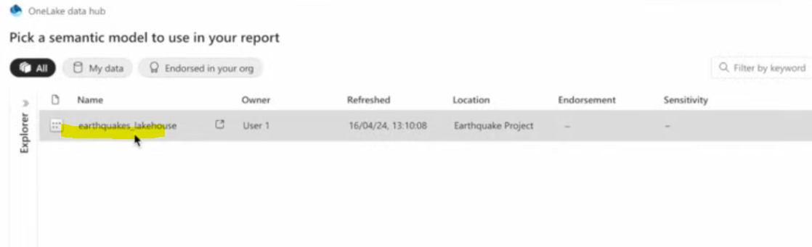

Data factory experience

Create a new pipeline
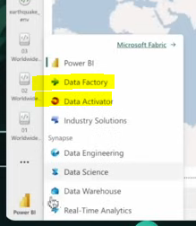
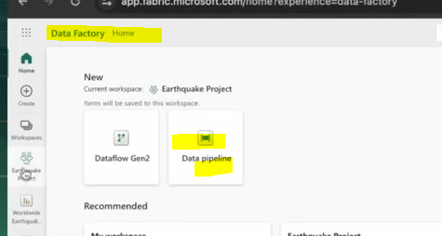
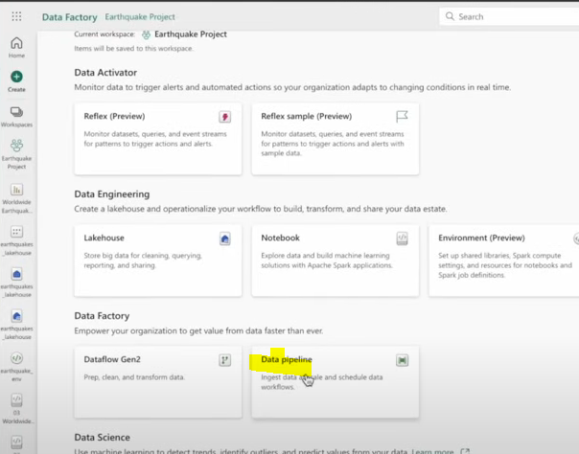
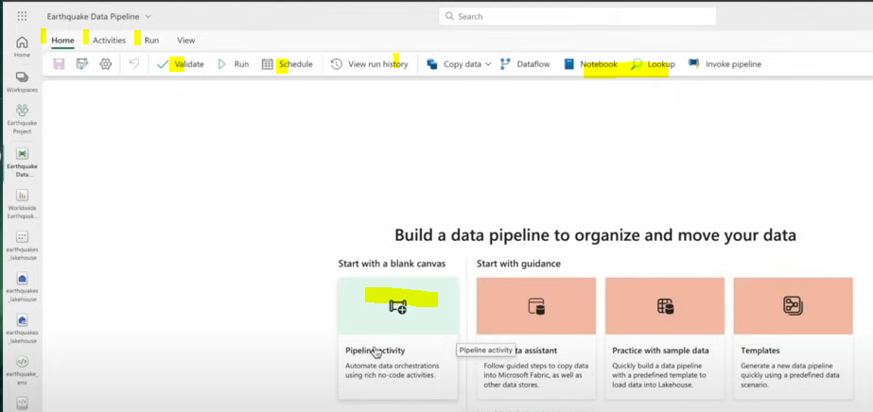
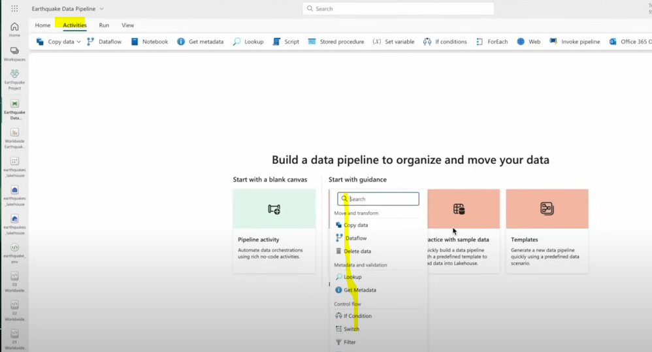

Pipeline with notebook activity (Using parameters)
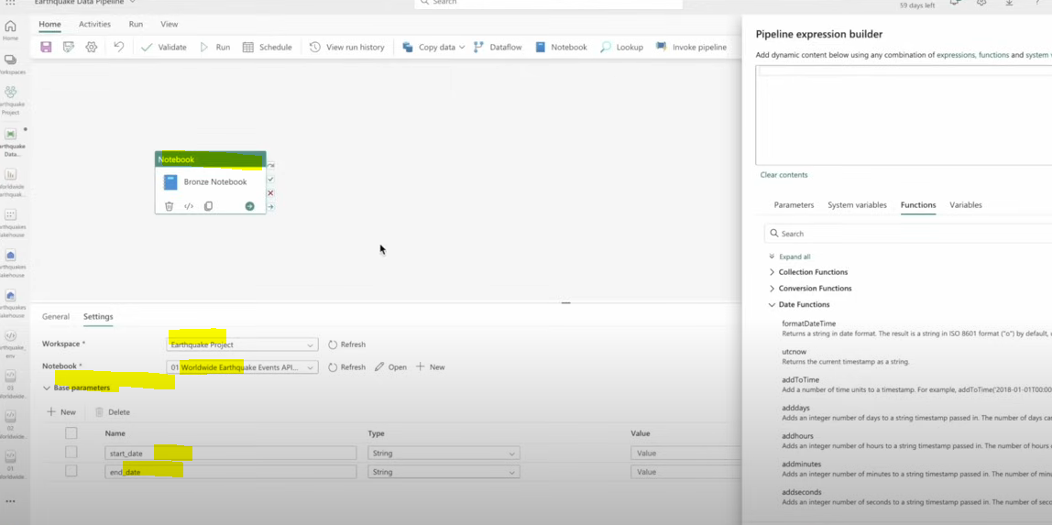
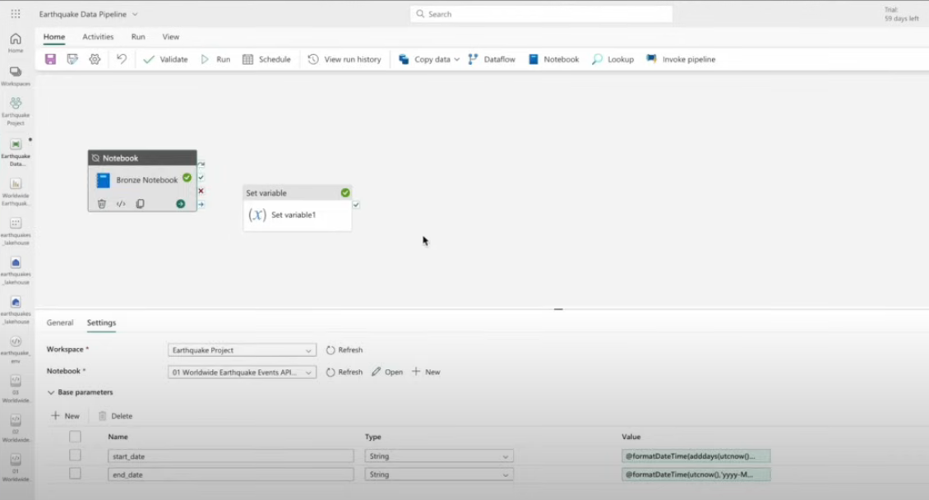

Processing (on schedule)

